

MATES Computer Science

**Senior Capstone Project Bi-Weekly Progress Report**

| Project Title | Journal Time! |
| --- | --- |
| Team Members | Shayne Lada, Ava McNabb, Lauren McNaboe |
| Dates Covered by Report | 3/11/24 - 3/22/24 |
| Link to Github | <https://github.com/code-shayne/journal-time-/tree/main> |

# **Summary of Project**

Journal Time! is a web app that allows users to journal and store entries online. The web app would provide prompts or free-journaling options and save all entries to unique user accounts. Users can also track emotions by indicating what they are feeling at the time of journaling. After each entry the user will receive a certain number of points or currency, incentivising journaling. The points can be used to buy accessories within the website such as different prompt packages, website themes, or journaling pets. The journaling pets would be avatars that live on the interface and encourage the user to journal and provide motivational messages. Points could also be used to customize and feed/play with pets. Users can track their journaling progress and view graphs and summaries of their emotions in a separate space on the web app. Email notifications can be scheduled to remind the user to journal or sent if the account hasn’t been used for 2 weeks. This project will encourage journaling, which is a useful practice for mental health and wellbeing. It will also make the process more accessible and fun for the users.

1. Summary of Progress this Period

Shayne and Lauren both worked on buttons basically the whole time. Ava researched database setup and began planning a database to efficiently manage user information. When Shayne implemented her emotion buttons on the main page, the buttons on the login page no longer worked. After trial and error and testing the original code, the buttons on the login page never worked! Basically, this sprint was focused on troubleshooting. Granted, we probably spent way too much time on these issues, but they now work to a certain degree. Overall, not much progress has been made, but we definitely learned a lot.

# **Detailed Progress this Period, separated by Team Member**

Lauren - I too aimed to do more this period. I followed a tutorial on how to make a login/signup page, but the tutorial was broken :D. Since Shayne changed the button denomination (?) to classes, I thought the problem was somewhere in the Javascript or the CSS file. In the CSS, I called all buttons to style them, but when Shayne added new buttons onto the main stylesheet, it changed their whole style as well. I fed the Javascript file, the HTML section of the login page, and the CSS sheet into ChatGPT, and it said everything looked right and it should work. Way too far into this, I decided to copy and paste the exact code from the tutorial into three files and guess what… it didn't work!!!! So I found a new tutorial and I need to tweak it to match the rest of the style of the website.

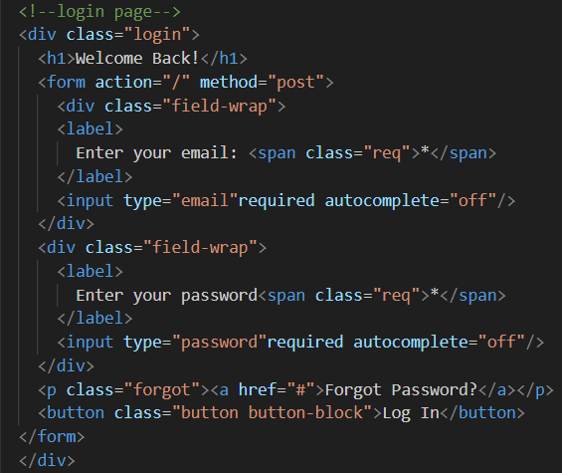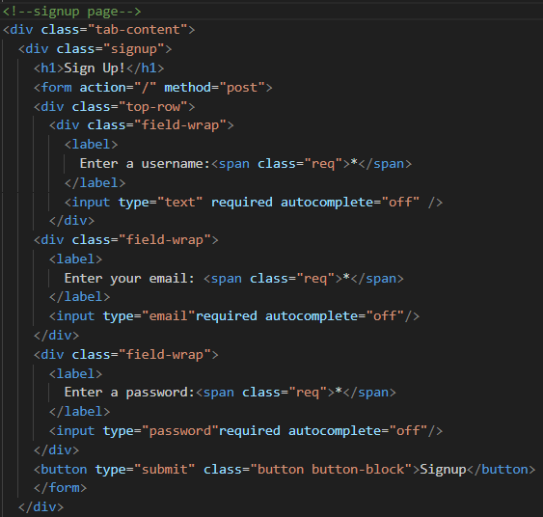

Login HTML Signup HTML

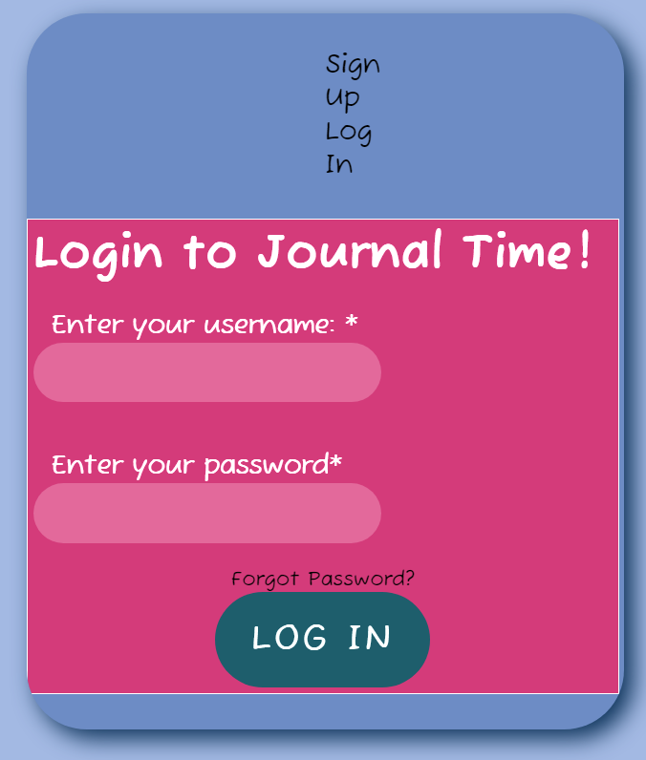

DON'T LOOK ITS UGLY RIGHT NOW

this will be fixed I promise you

Shayne -

I aimed to do more this period but the emotion buttons took up a lot of my time. They are still not perfect either and took a lot of tweaking and asking ChatGPT how to fix errors.

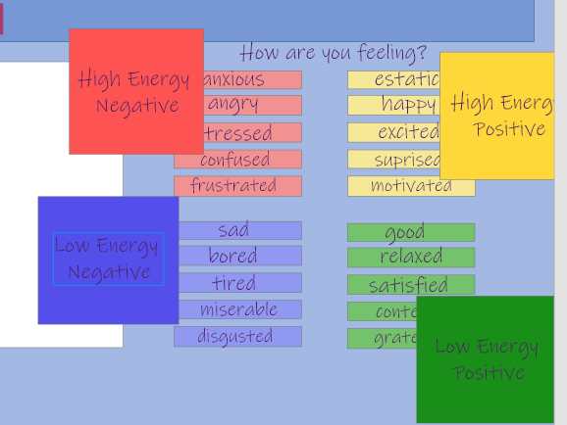

This is the layout I decided on in Adobe XD for the buttons. The bigger buttons describing the emotion groups would disappear when clicked, revealing the more in depth options underneath. The design is based on an emotion tracking app that I use called How We Feel that has a similar concept to its layout.

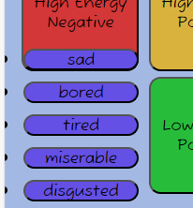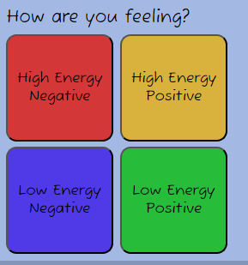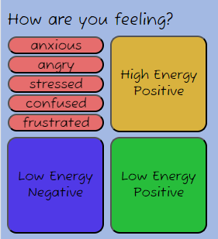

This is the coded design. I used JavaScript functions to make the group buttons disappear when clicked and for the smaller buttons to appear like they are in the second picture. I had to change my initial functions to make it so all the other buttons reappear when a new button is clicked. I also made separate functions for each of the smaller emotion button groups so they would disappear/appear at the correct time. The functions are a little convoluted and there may be a simpler way but they work how they’re supposed to so it's good enough for me. I also wanted to put the JS as a separate file and connect it to my HTML but when I do that the functions don’t work so I just used the <script> tag in HTML instead.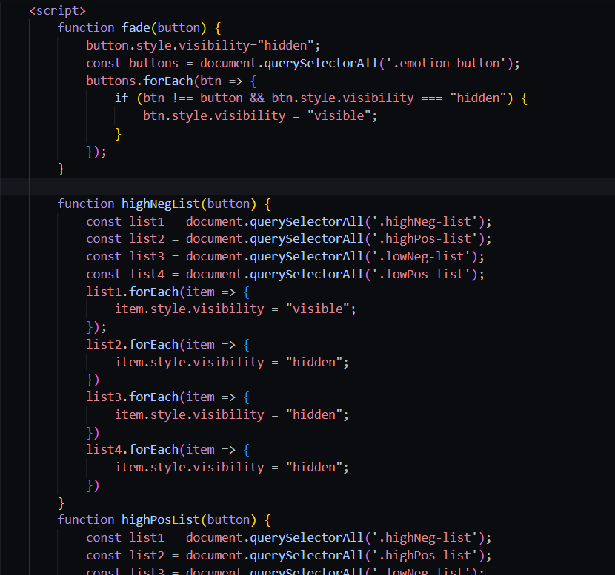

The buttons function and look good on a smaller screen like the one I use to see the website while also coding, but when I bring it to full screen they stretch out and the bullet points from the unordered list of emotions show. I don’t know why this happens and tried adjusting the padding and margins to fix it to no avail. Also, when I use list-style-type: none; (which is the only function that will remove the bullet points on a list as far as my research has shown) the list buttons all just stack on top of each other like in the picture. I tried removing all the other CSS modifications I made to see if they were interfering but that did not help the problem.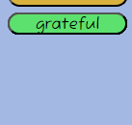

Besides the buttons I fixed some of the changes that happened when merging me and Lauren’s code (and may have broken hers). I also worked through some JS tutorials to better understand functions and how to connect them to HTML and CSS. Additionally, I updated the home page to account for a bigger input box. I want the emotions to go next to the journaling space, but I don’t know why there is a gap on the top of the emotion section. Changing the top margin doesn’t do anything so I’m not sure what is causing it.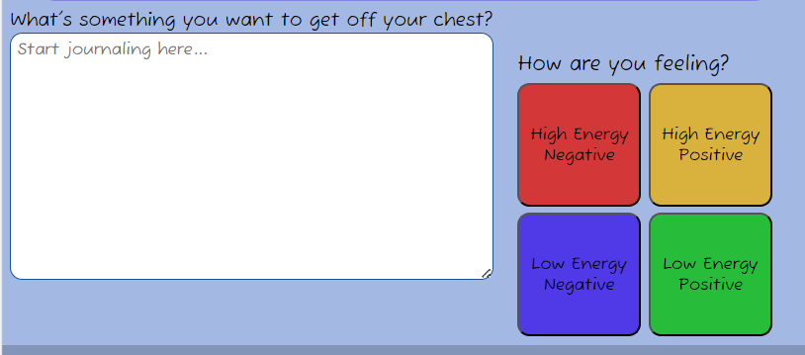

Ava -

This sprint I focused mainly on planning the structure of our database to power the web app. This included refreshing my memory on SQL, researching database conventions, and deciding on the best way to organize information. I also continued my JavaScript and Backend Engineer Codecademy courses to prepare for other tasks we will pick up in the future.

Sources I found:

<https://www.sqlshack.com/learn-sql-create-database-create-table/>

This link walks the user through the basic terms and code to start a basic SQL database. It goes through statements to create databases and tables, using a SQL server, and explains basic SQL syntax. It was a good source to get me acquainted with the relationship between tables and databases.

<https://support.microsoft.com/en-us/office/database-design-basics-eb2159cf-1e30-401a-8084-bd4f9c9ca1f5>

This article is much more in depth about the conventions and good practice in database structure. It went in depth into fields, records, tables, and the relationship between each type of data point. I also learned good practices to keep the data organized and efficient, and to avoid redundant entries.

After reading those articles and practicing with SQL, I decided the best way to deal with the data we currently plan to collect would be to split it into two tables:

| User Information | Journal Entries |
| --- | --- |
| * UserID * First name * Username * Password * Email | * EntryID * User * Entry title * Entry body * Date entered * Emotion |

The next step would be to implement these as tables and file them into a database, ideally using username to link the two tables. To uniquely identify each record and reduce redundancy, the tables have no overlapping data except for the user, and each record has a unique ID. The most challenging part of creating this database will be connecting it to user input to make the login, signup, and journal entry boxes fully functional.

# **Difficulties Encountered this Progress Period**

There were multiple difficulties encountered when making the emotion buttons, as explained in Shayne’s progress section. To solve many of these problems, I turned to the internet and ChatGPT which helped me understand where I went wrong and adjust my code to make it work. However, there are still some difficulties that I do not know how to fix and that are very annoying. We also had some difficulties when merging our code together which created conflicts in our CSS. To fix this we started working more on separate branches. When making the code more readable and easy to understand, a lot of things got messed up. This led to the discovery that some things never worked at all. But we pivot and we persevere. Now we have a new login page that needs to look nicer, but has functions attached to it and has places to enter your information.

# **Updated Trello Board and Discussion**

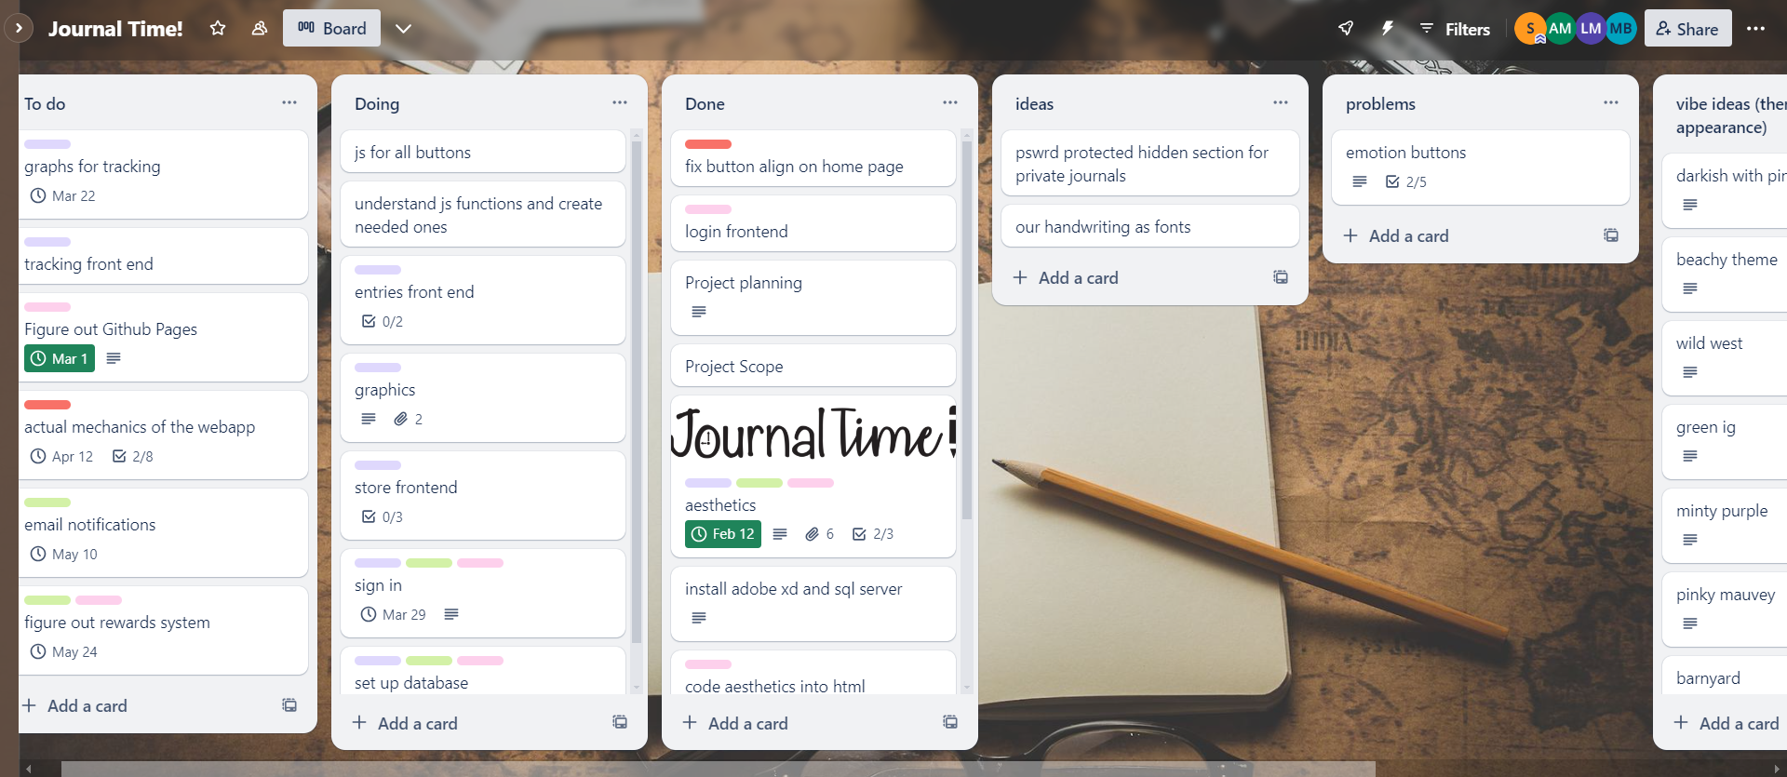

<https://trello.com/b/5P60HsFp>

We added a problems and ideas tab to better sort the tasks we have to do.

# **Tasks to Be Worked on in Next Progress Period** **Lauren** -

* fix login page to be able to register an account
* set up SQL database and connect to user input
* encrypt database

Shayne -

* design the tracking page in Adobe XD and implement it with HTML and CSS
* code the storing and displaying of emotions on graphs and charts
* create more filters on the entry and store pages and finalize design for how past entries and store items appear

Ava -

* implement more javascript functions into the HTML and CSS
* creating sql database for user information and entires
* connecting database code to the front end

# **Additional Information**

We have a good setup on the front-end and aim to focus on more of the back-end engineering now. Setting up the SQL database will be a top priority for the next sprint. Although we didn’t get as much done as expected in this sprint, it was still very insightful. We ran into some complicated issues, but now that we have fixed/are fixing them, we should be able to move on after break.